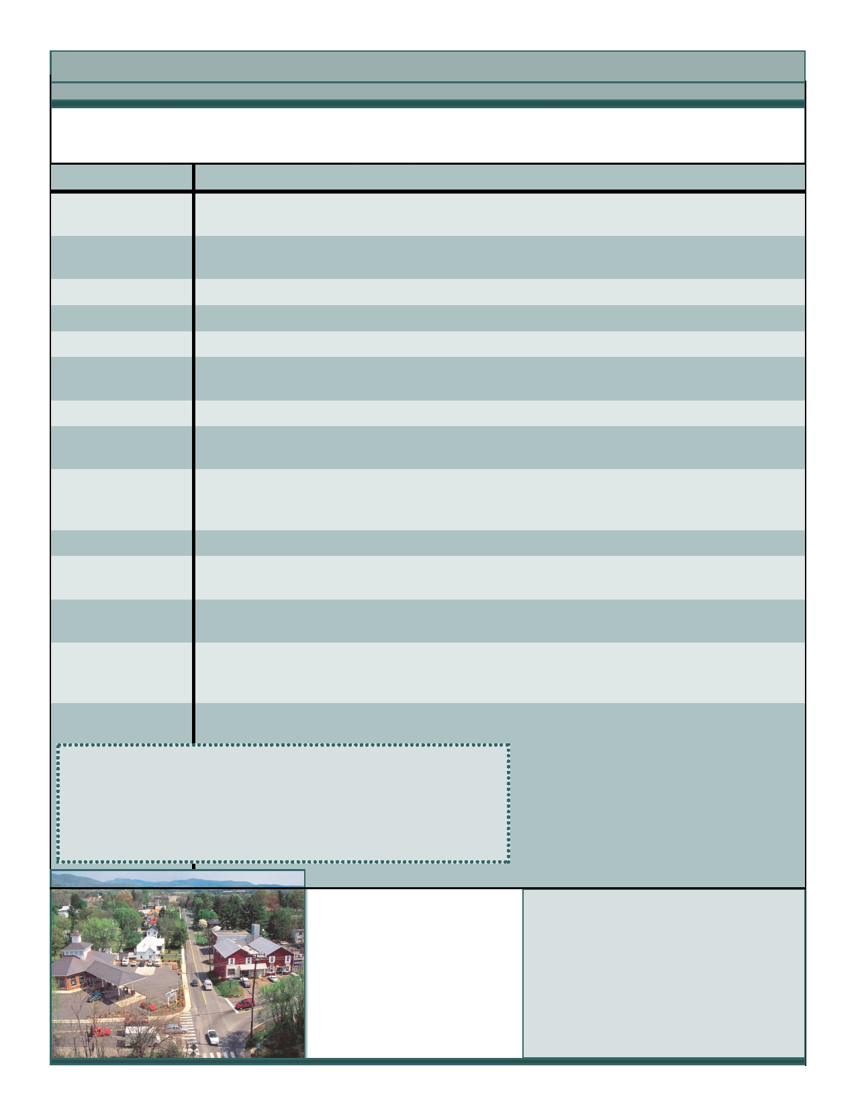
Crozet Community Advisory Council Focus Areas

At their public meetings in the Fall of 2011, the CCAC revised the focus areas of the Council. We welcome
anyone with an interest in these areas to join us in gathering community input in the following areas:

Focus Area

Downtown

Eastern Crozet:

Western Crozet
Northern Crozet Southern Crozet
Parks/Trails

Library
Police/Fire-Rescue

Utilities—Water,
Sewer and Solid
Waste, Recycling

Transportation Issues

Schools

Economic
Development

Historic District

Description

Downtown zoning, streetscape construction, building of the library, contact with Downtown Business Association
Eastern connector planning, rezoning proposed for
Eastern Crozet, old ConAgra and Acme Visible Records
West Village, Jarmans Gap Road, Old Trail matters
Old School, Crozet Station
Development on Rt. 250 and Yancey Mills

Promote and facilitate walking and biking trails and reporting on park facilities at all parks

New Crozet Library (www.albemarle.org/newlibrary)
Contact these various agencies, get a picture of the issues
facing these agencies as Crozet grows

Keep informed of the proposed recycle center, water and
treatment facilities.

Keep informed of transportation issues and projects

Linking CCAC with the local schools, PTOs, the
schools’ population, and the School Board.

Monitor and promote the economic development of the
greater Crozet area. Tourism. Rural Economic development

Assist in final application to state for Crozet Historic District

Ombudsman

Supporting Members

Do you have information or comments about the focus areas?
Focus area ombudsmen and supporting members will be gathering information
from community members about their specific areas, and they welcome your
input. To discuss your thoughts, please contact one of the CCAC members

